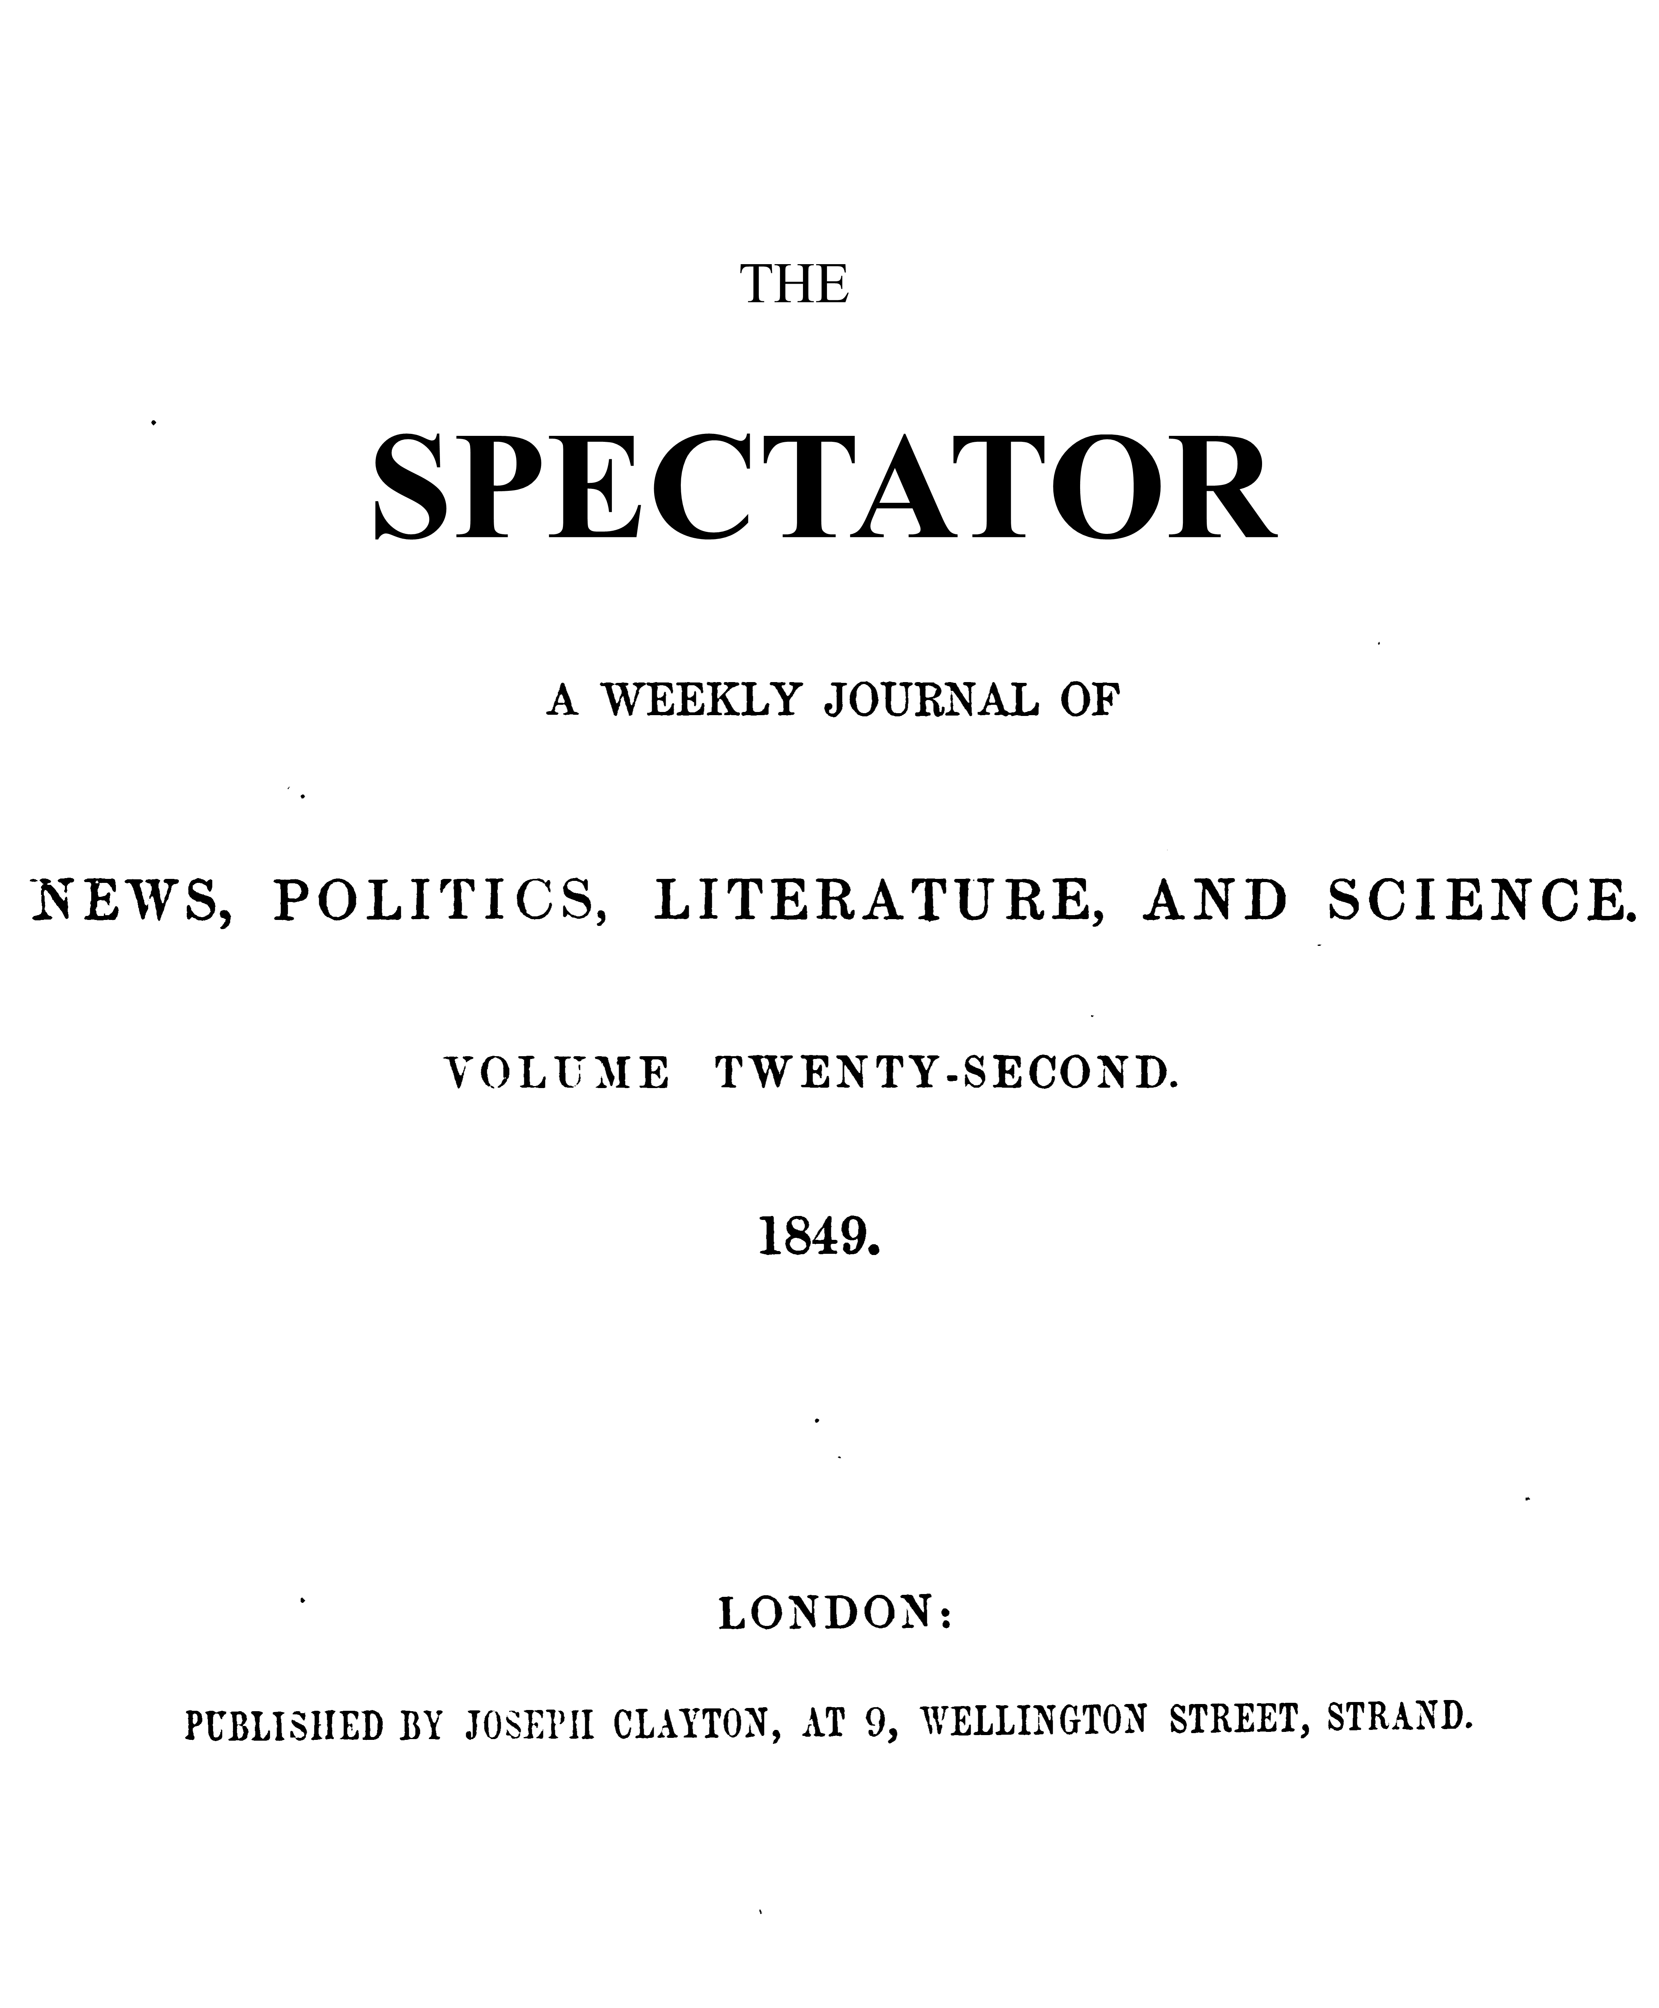

BRITISH INTERVENTION IN SICILY
Replying to Lord Stanley, on Tuesday, the Marquis of Lansdowne » stated that there was undoubtedly some foundation for the report that a ^{i} Government arms-contractor had been allowed to receive back arms out of; Government stores in order to furnish them to the Sicilian Government de facto, in pursuance of a contract made with that Government.
But when the permission so given came to be considered with more care by the 1 members of the Government, although it did not appear to them to amount to HQ; act of direct interference in hostilities, it appeared so liable to misconstruction as an act of indirect interference, that they came to the deliberate opinion that it i was matter of regret that that permission had not been withheld; and, in consideration of the preeminent power of the British Government in comparison with that of the Government of Naples, they determined that the British Government should be beforehand in tendering to the Government of Naples satisfaction, if satisfaction should be required. Our Government was therefore fully authorized, if called upon, to explain the amount and extent of its interference, and to state that it had occurred through inadvertence, and that measures had been taken to prevent the recurrence of any such inadvertence in future.
Lord Brougham objected to the frequent use of the term “Sicilian Government: he should no more consider the Government of the Sicilian insurgents to be the Sicilian Government, than he should consider Smith O’Brien’s Committee the Irish Government Lord Lansdowne explained, that the term was not an acknowledgment of the Government of the insurgents, but was an expression of the notorious fact that the Government of the insurgents was the Provisional Government of Sicily.
The subject was made a topic of debate in the House of Commons also, on a formal motion by Mr. Bankes, on Wednesday, for…………. “an account of all Ordnance stores returned from that department to any contractor in the year 1818, for the purpose of being sent to the Sicilian insurgents in arms against her Majesty’s ally the King of the Two Sicilies, with the consent of her Majesty’s Government.”
Mr. Bankes reviewed generally the conduct cf our relations with the Italian Sovereigns; especially criticizing the policy of Lord Minto’s mission, and the mode in which the mission was carried out.
Lord Palmerston replied, with somewhat of tartness in his manner, by a general defence of his Italian policy; not overlooking some inaccuracies of detail which he pointed out in Mr. Bankes’s remarks. In guarded language he vindicated the proceedings of the Sicilians, as defenders of violated rights, rather than as rebels against legal government; and he launched into an oratorical glorification on the theme of this country’s stability amidst general revolution, with a view to assume the credit of a vigorous and influential Governmental policy at home and abroad.
Mr. John O’Connell and Mr. Hume each found in Lord Palmerston’s remarks a handle whereby to bring in the topics of Repeal and Retrenchment,—the first, in his defence of national right to demand independence for Ireland; the second, in his high-flown description of the moral power and influence of his country abroad, which would obviate the necessity for great physical armaments.
Lord John Russell corrected erroneous impressions of what had occurred in the Cabinet on this question.
It was assumed, “that it appears from the statement of a noble friend of mine in another place, that the Cabinet had differed from my noble friend (Lord Palmerston) in opinion, and that what the latter thoughts right course of proceeding they thought a course not justifiable. Nothing of this kind occurred. Some months ago, my noble friend received this application from the Ordnance. I sup|»ose at the time he did not pay exceding attention to it, and he said lie thought there was no objection to granting the application,—not that the stores of the Queen should be entirely denuded and that this country should be left without arms, but that the eight or nine guns asked for should be given back to the contractor. Some time afterwards, my noble friend said to his colleagues, that he did not think that that proceeding could be strictly justified; and he proposed that instructions should be given to our Minister at Naples to offer an explanation, if called on, and to express regret for what had been done. So far, then, from there being any difference between my noble friend and his colleagues, it was at the suggestion of my noble friend himself that this latter determination was taken.”
Lord Palmerston was quite willing to grant the return; but he objected to the use of expressions tending to pledge the House to Mr. Bankes's political opinions: he proposed to amend the motion by the omission of such words as “the Sicilian insurgents in arms against her Majesty’s ancient ally.”
Mr. Bankes consented to omit the word “insurgent”; and proposed to substitute for the words “her Majesty’s Government,” at the end of the motion, the words “her Majesty’s Secretary for Foreign Affairs,” as he understood it was inaccurate to say that the arms were issued with the “consent of her Majesty's Government.”
Lord Palmerston did not adopt this suggestion, but called for a division; and his amendment was curried, by 124 to 39. The amended motion was then agreed to.

CORRUPT ELECTIONS
The following Members were nominated on Monday to form the Committee on the Bribery at Elections Bill—
Sir John Pakington, Lord Ashley, Sir Frederick Thesiger, Mr. Bouverie, Viscount Mahon, Mr. Brotherton, Mr. Valole, and Mr. Legh.
On the motion that Sir John Hamner be one of the Committee, Colonel Sibthorp divided the House: but the division showing that fewer than 40 Members were present, the motion dropped, and the Speaker adjourned the House.
When the subject was taken np again on Thursday night, Colonel Sibthorp renewed his motion, and made some show of opposition to Sir John Hammer; but did not persevere; and the following Members were added—
Sir John Hanmer, Mr. Horsman, Mr. Wrightson, Mr. Napier, Mr. Maitland Mr. MulliDgs, and Mr. Sheridan.

